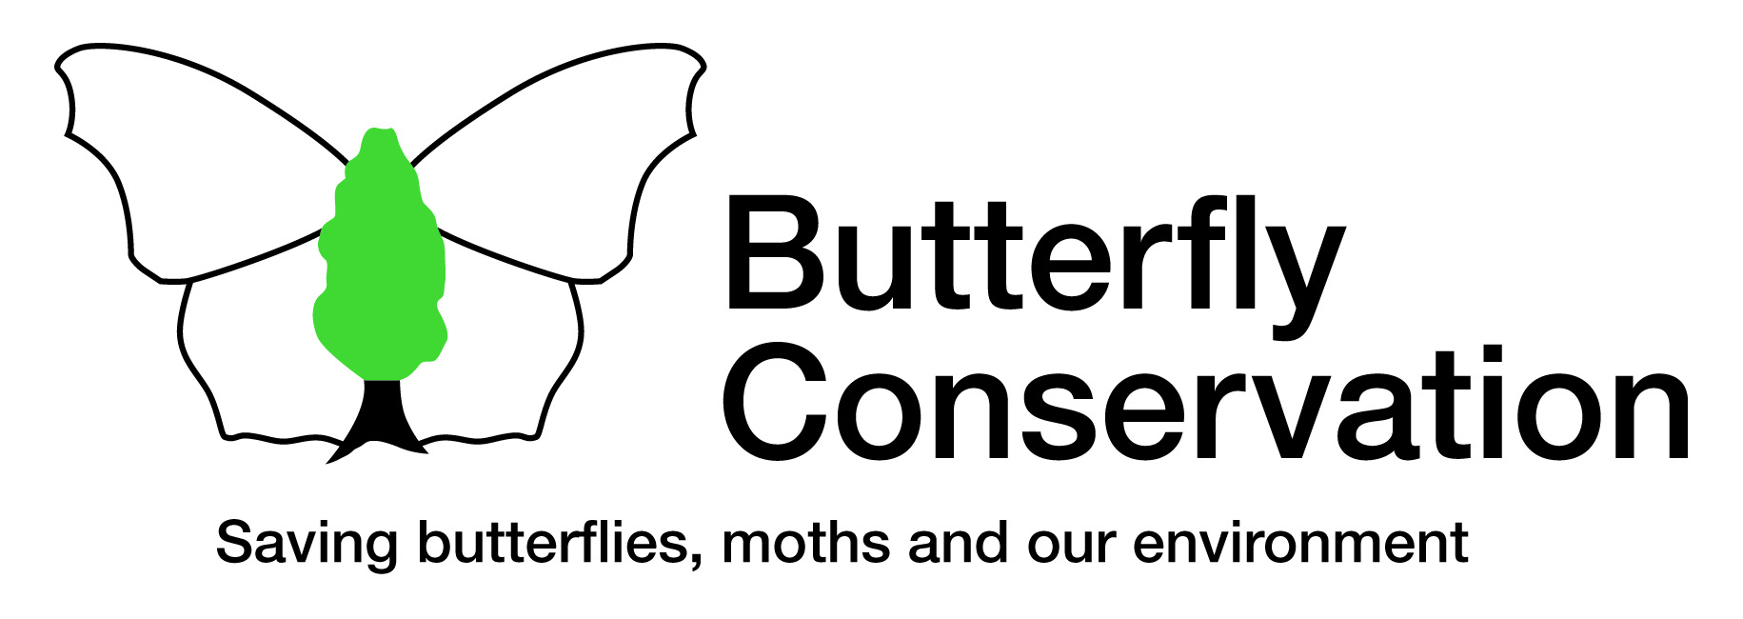

Dear Member,
Butterfly Conservation North East England Branch has published a book called the Butterflies of North East England. This book gives a detailed account of the current state of each species of butterfly regularly seen in our region. Each species account is illustrated with photographs, line drawings, maps and graphs. There are other sections discussing the causes of changes in distribution, looking at what may happen in the future and a section on extinct and vagrant species.

The book is now available for members to buy at a price of £5 plus £1.60 postage and packing. If you would like a copy please fill in the request slip below and send it together with a cheque for £6.60 made payable to 'Butterfly Conservation North East England Branch' to :-

David Stebbings
20 Purley Gardens
Newcastle upon Tyne
NE3 3DJ
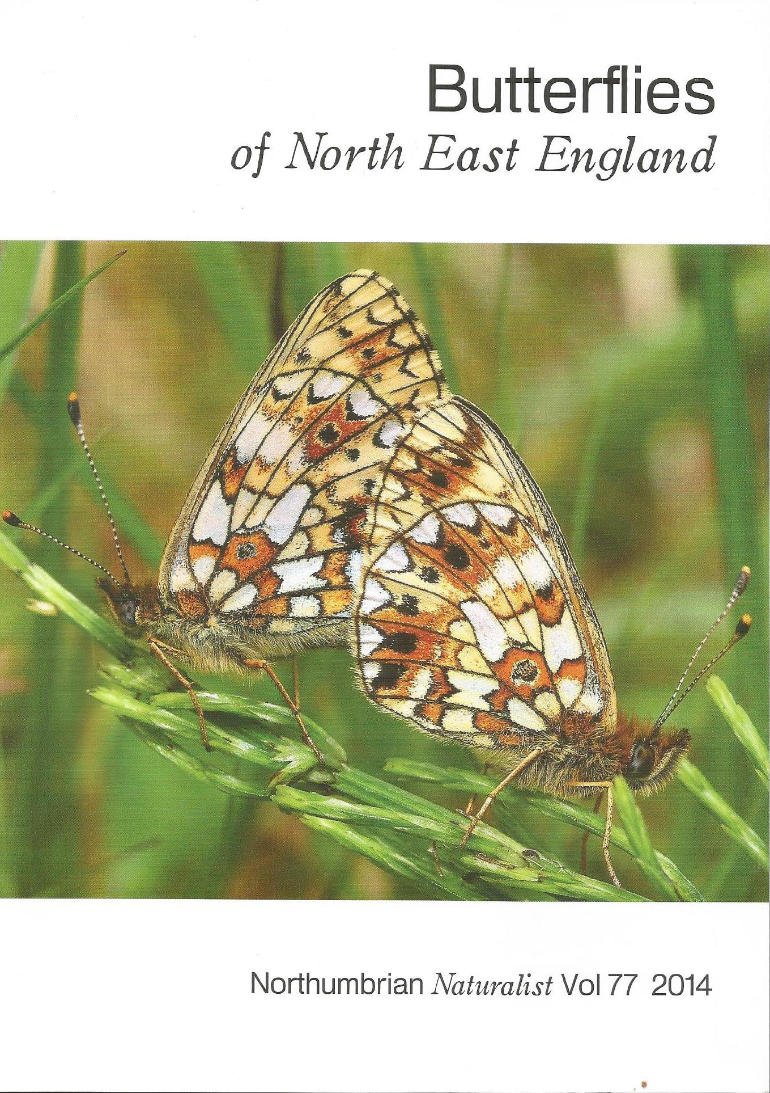
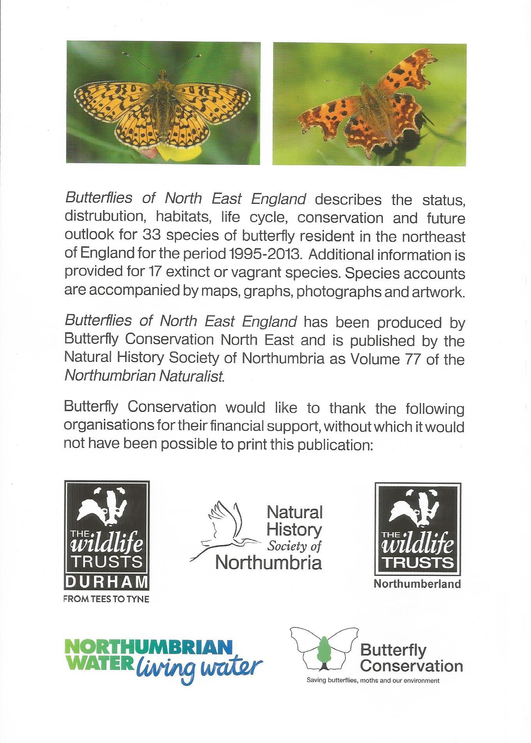

------------------------------------------------►◄------------------------------------------------

Name.................................................Number of Copies.......Amount Enclosed............

Delivery Address............................................................................................................

.........................................................................................................................................

Butterfly Conservation
Company limited by guarantee, registered in England (2206468)
Registered Office: Manor Yard, East Lulworth, Wareham, Dorset, BH20 5QP
Charity registered in England & Wales (254937) and in Scotland (SCO39268)

